**ACKNOWLEDGEMENT**

This project has been executed as a mandatory component of the Computer Science (Subject Code: 083) curriculum prescribed by the Central Board of Secondary Education. In accomplishing this academic requirement, I have earnestly assimilated conceptual understanding and analytical perspective cultivated through formal instruction and independent study. The creation of this work demanded disciplined organisation, intellectual depth, and sustained perseverance, rendering the process both rigorous and enriching.

I deem it a privilege to formally acknowledge the encouragement and assistance extended during this scholastic pursuit. I express my sincere gratitude to the Almighty for bestowing resilience, determination, and clarity of thought throughout the endeavour. I convey profound respect to our esteemed Principal, Ms. Jyotsna Ranjan, whose visionary leadership and consistent motivation fostered an environment conducive to academic growth. I am deeply obliged to my Computer Science Facilitator, Mrs. Sonia Shah, for her discerning mentorship, scholarly insight, and constructive guidance during the formulation of this assignment.

I also recognise the cooperation of the school administration, whose provision of essential resources and a supportive academic atmosphere enabled uninterrupted progress. I remain sincerely thankful to my parents and peers for their encouragement, thoughtful input, and moral reinforcement, which significantly contributed to the successful completion of this work.

This project stands as a reflection of the collective guidance, goodwill, and support received from all those acknowledged above. (

# CERTIFICATE

This is to certify that the project entitled *“****General Store chatbot****”*. is a bonafide work done by Shubh Tiwari of Class 12, (Academic session 2025-26). This project has been carried out under the direct supervision of Mrs. Sonia Shah.

……………………………………………… ……………………………………………

Signature of External Examiner Signature of Educator [Mr. / Ms ]

…………………………………………………………………………… Signature of Student

CBSE Roll No. …………………………………………………

# TABLE OF CONTENTS

* Aim of the Project 1
* Software and Hardware Requirements 2
* Tools and Technologies Used 3
* Project Description 4
* Algorithm 5
* Python Code 6-11
* Output 12-15
* MySQL Code 16-23
* Reverse Engineering 24
* Features of the Project 25
* Limitations of the Project 26
* Bibliography 27
* QR Code and Link 28

# AIM OF THE PROJECT

The aim of this project is to develop a simple, menu- driven General Store Management System using Python and MySQL to efficiently manage product details, check item availability, generate customer bills, update stock automatically, and maintain sales records in a database.

1

**SOFTWARE AND HARDWARE**

**REQUIREMENTS**

## MinimumSoftwareRequirements-

* 1. Operating System: Windows 10
  2. Programming Language: Python 3.8
  3. IDE: Python IDLE
  4. Spreadsheet Software: Microsoft Excel 2016

## MinimumHardwareRequirements-

* 1. Processor: Intel Pentium Dual Core
  2. RAM: 3 GB
  3. Storage: 200 MB free disk space
  4. Input Devices: Keyboard, Mouse
  5. Output Device: Monitor

2

**TOOLS AND TECHNOLOGIES**

**USED**

* + - Python Programming Language – Used to develop the logic of the General Store Management System, including menu handling, billing, and stock management.
    - MySQL Database – Used to store product

details, stock information, and sales records in an organized manner.

* + - mysql.connector Module – Used to establish a connection between the Python program and the MySQL database.
    - SQL – Used to insert, update, and retrieve data from the database tables.
    - Python IDE (IDLE / VS Code) – Used to write, edit, and execute the program.

3

**PROJECT DESCRIPTION**

This project is a General Store Management System developed using Python and MySQL. It is designed to automate basic store operations such as managing products, checking item availability, generating customer bills, and maintaining sales records.

The system allows the shopkeeper to add new products, update stock levels, and view available items. Customers can interact with a rule-based chatbot to enquire about product availability, prices, and store timings.

The program ensures that:

* Product details are stored securely in a database
* Stock quantity is automatically updated after each sale
* Bills are generated accurately based on quantity and price
* Sales records are maintained for future reference This system reduces manual work, minimizes errors, and provides an efficient way to manage daily store operations using a simple, menu-driven interface.

4

**ALGORITHM**

1. Start the program
2. Establish connection between Python and MySQL database
3. Display the main menu to the user
4. Accept the user’s choice
5. If the user selects product management:
   * Add new products to the database
   * View available products
   * Update stock quantities
6. If the user selects chatbot interaction:
   * Accept customer queries
   * Display product availability and prices
7. If the user selects bill generation:
   * Accept customer and product details
   * Calculate the total bill amount
   * Store sales details in the database
   * Update product stock automatically
8. If the user selects sales view:
   * Retrieve and display sales records
9. Repeat the process until the user chooses to exit
10. Stop the program

5

**PYTHON CODE**

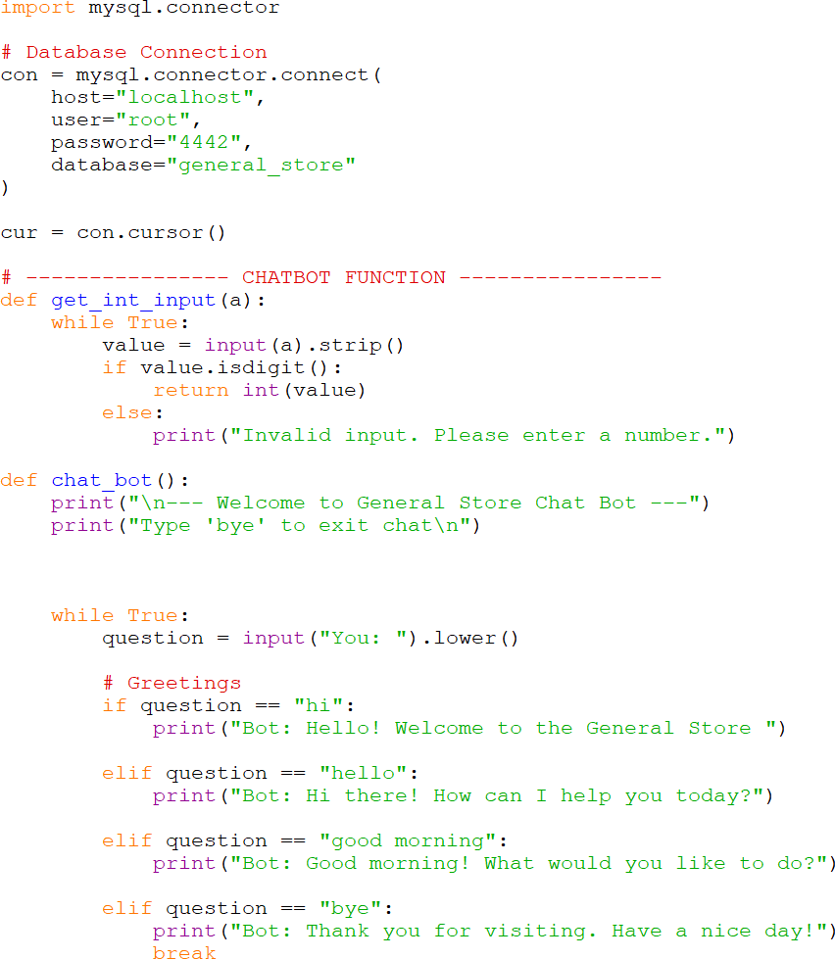

6

7

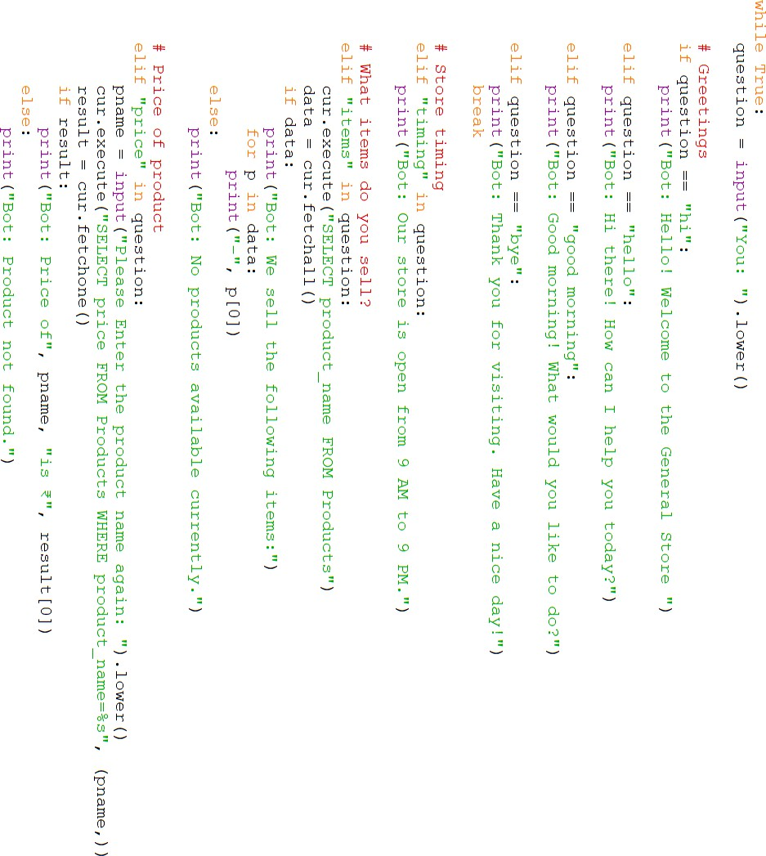

8

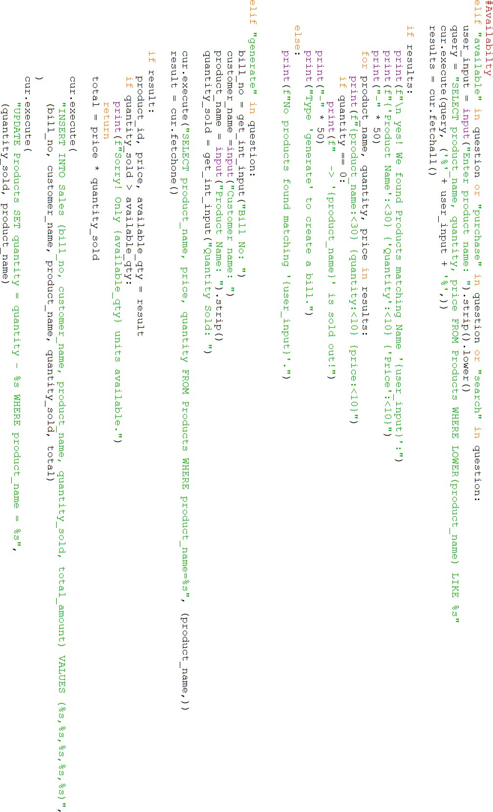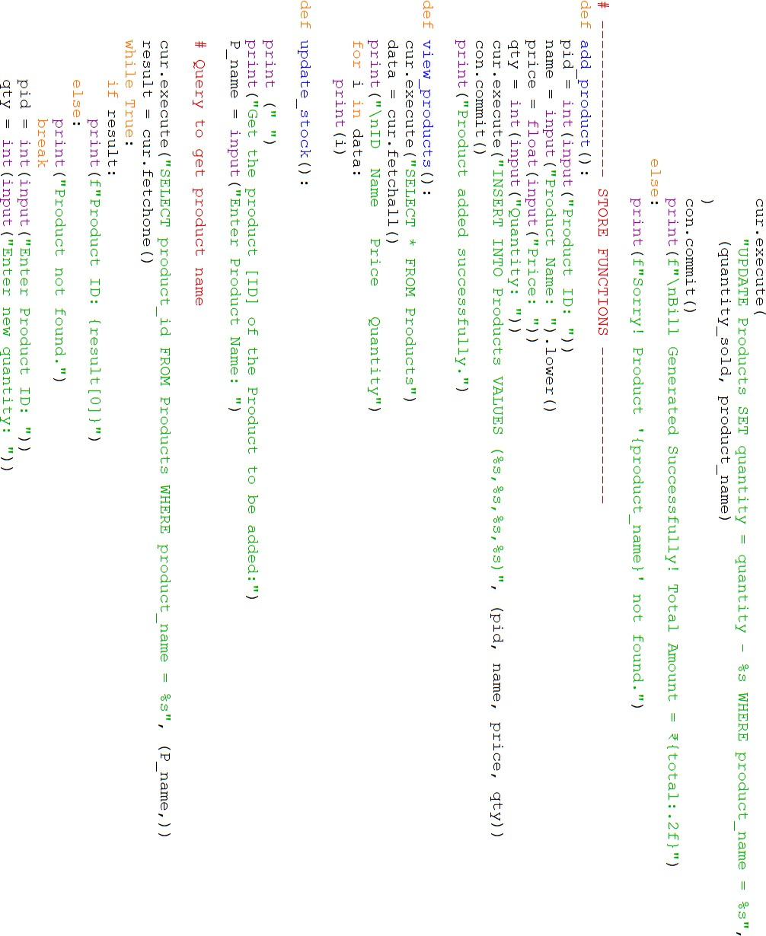

9

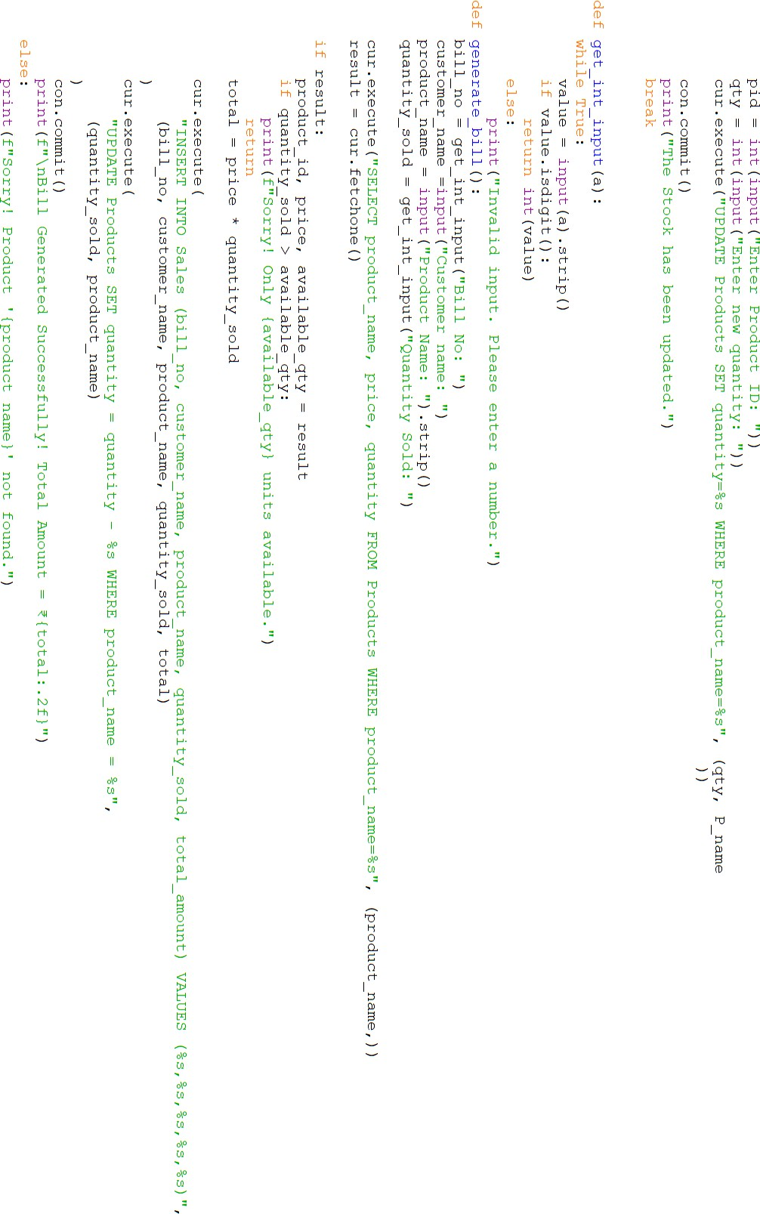

10

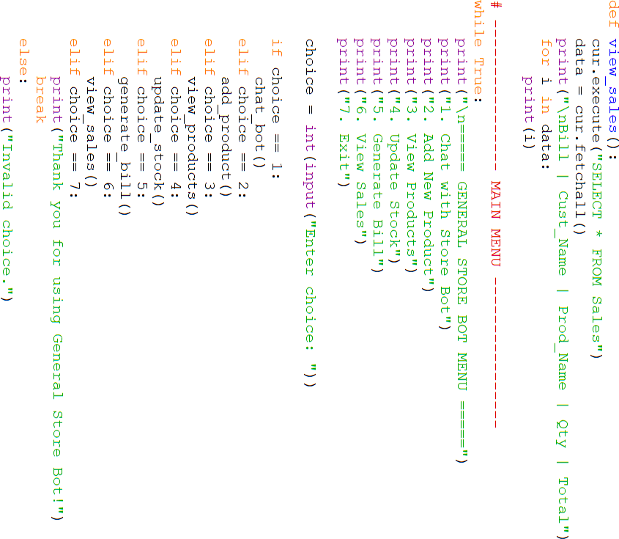

11

**MY SQL CODE**

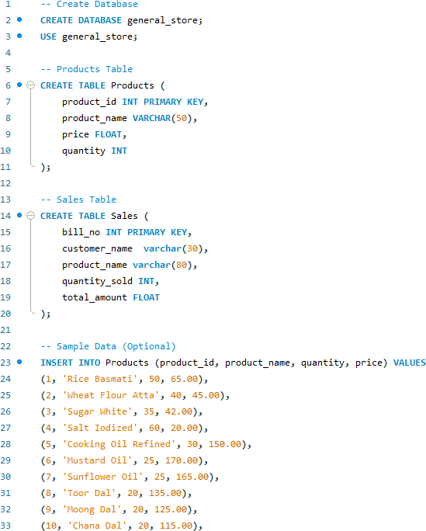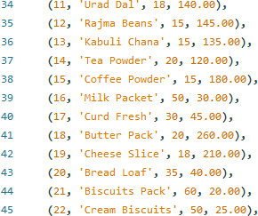

16

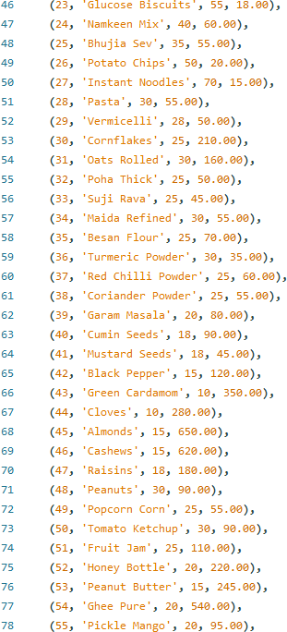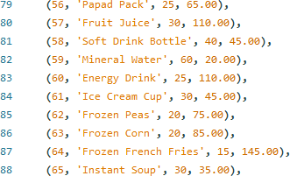

17

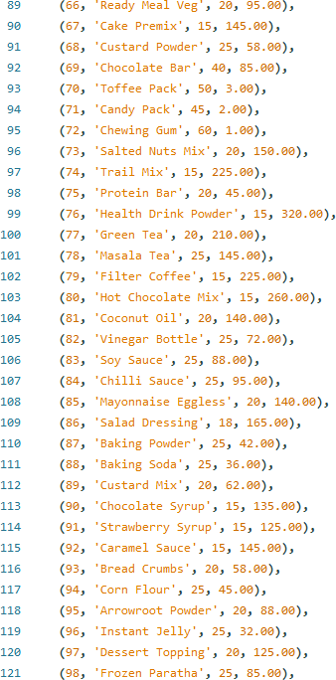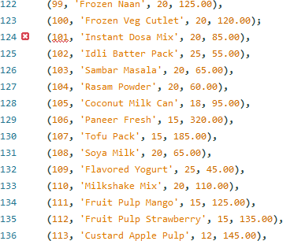

18

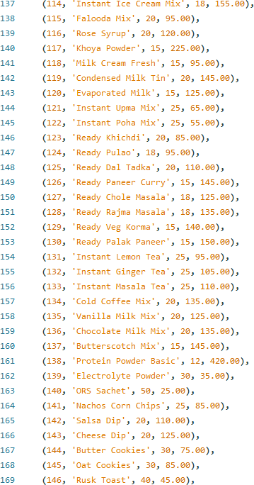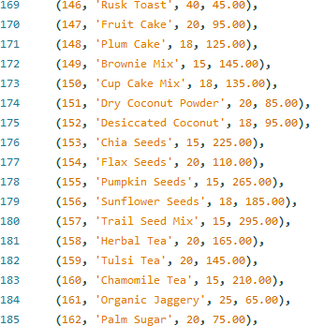

19

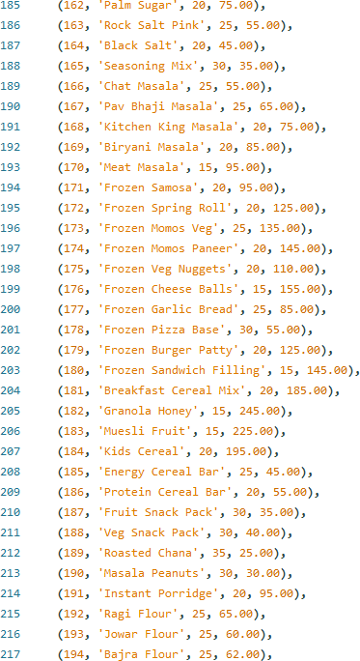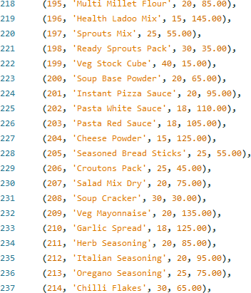

20

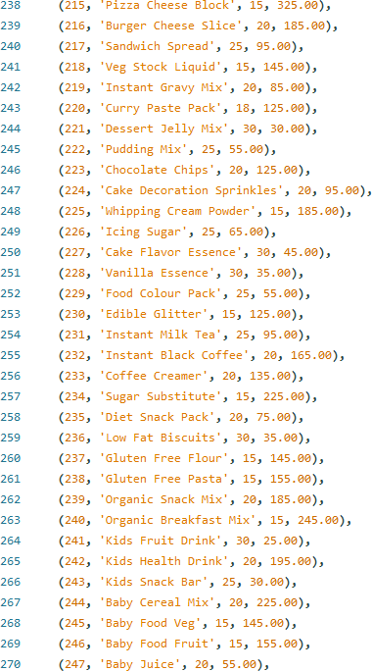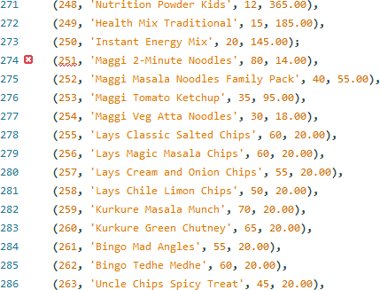

21

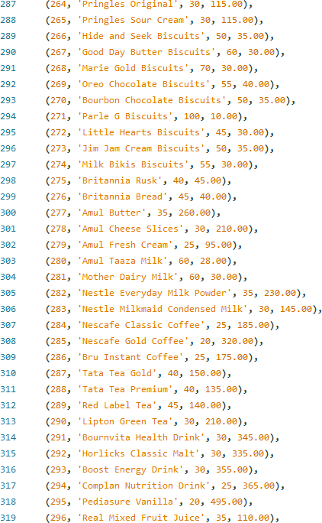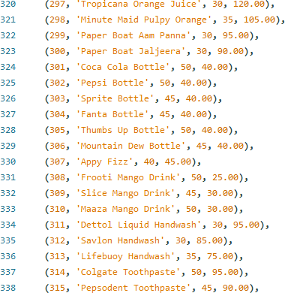

22

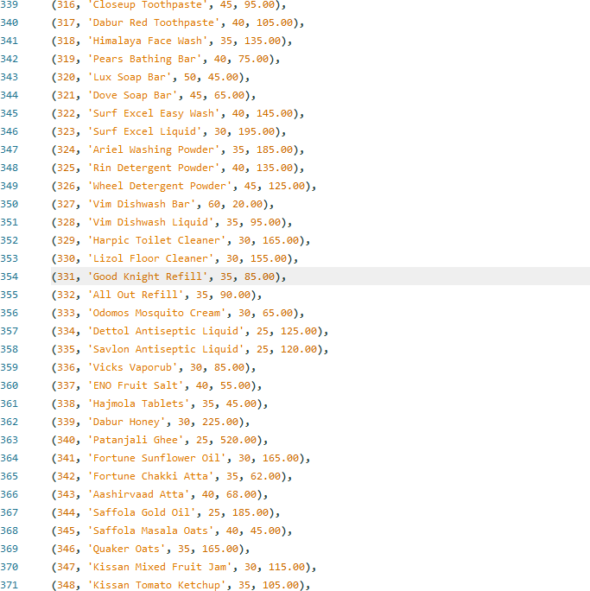

23

**REVERSE ENGINEERING**

(SQL Code)

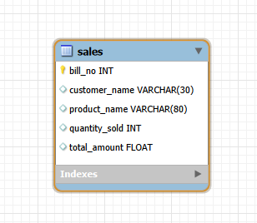

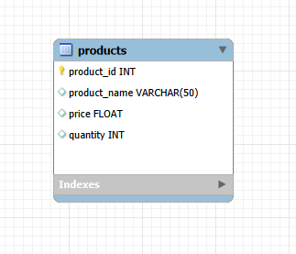

24

**FEATURES OF THE PROJECT**

* User-friendly, menu-driven program
* Stores product details like name, price, and quantity
* Checks product availability before billing
* Automatically generates customer bill
* Calculates total amount accurately
* Updates stock after every sale
* Stores sales records in the database
* Reduces manual work and calculation errors

25

**LIMITATIONS OF THE PROJECT**

* Designed for a small general store only
* No graphical user interface (GUI)
* Requires basic knowledge of Python and MySQL
* Works only on a single system
* Does not support online payments
* Limited error handling

26

# BIBLIOGRAPHY

1. NCERT Computer Science Textbook – Class XII
2. Python Official Documentation
3. CBSE Computer Science Syllabus (2024–25)
4. Microsoft Excel Documentation
5. Online Python learning resources

27

**PYTHON CODE OUTPUT**

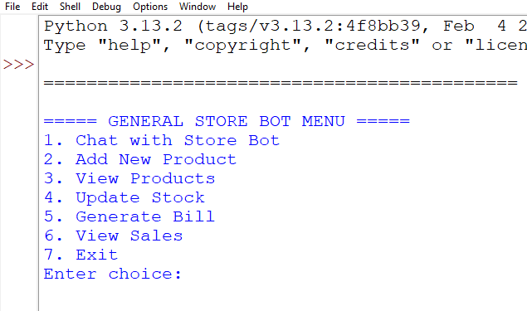

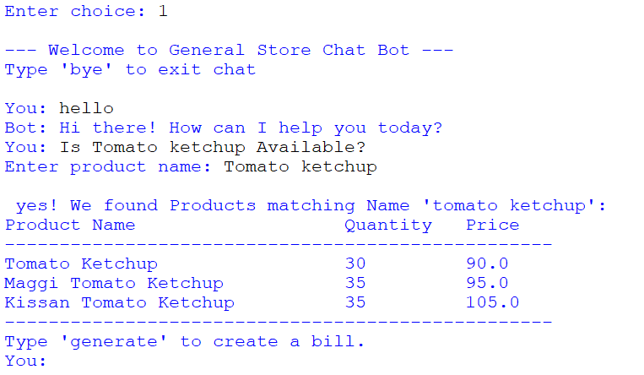

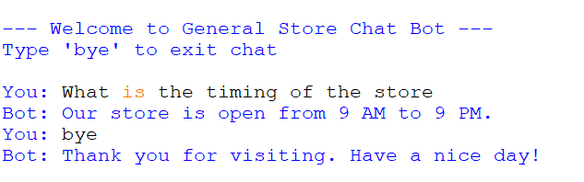

12

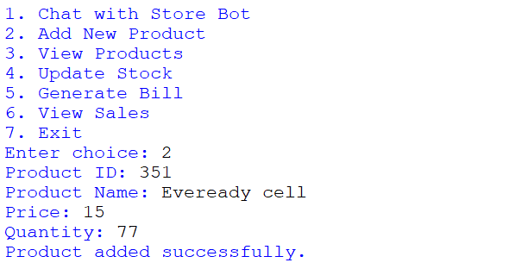

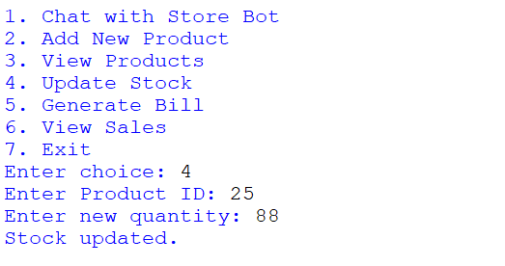

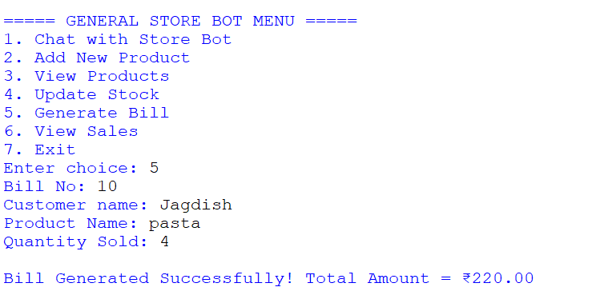

13

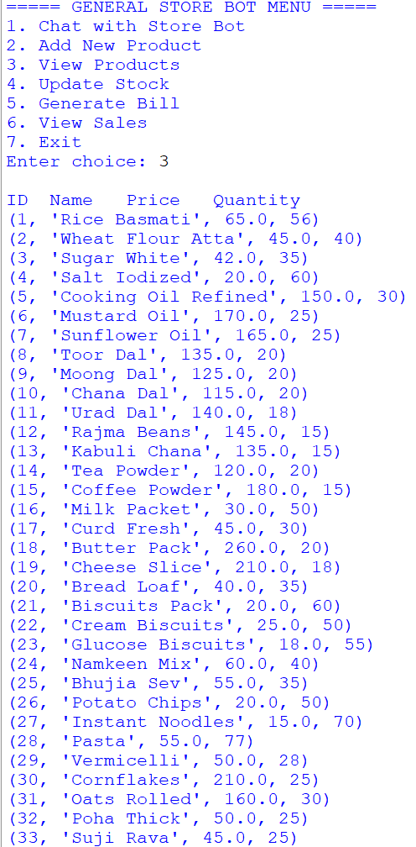

Etc. (Total Products=351)

14

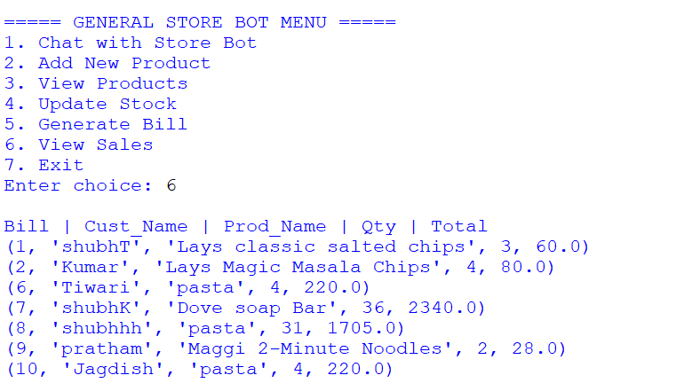

15